**Hithesh Shanmugam**

**CSC 578**

**Assignment 6**

**Problem 1: Erosion and Dilation**

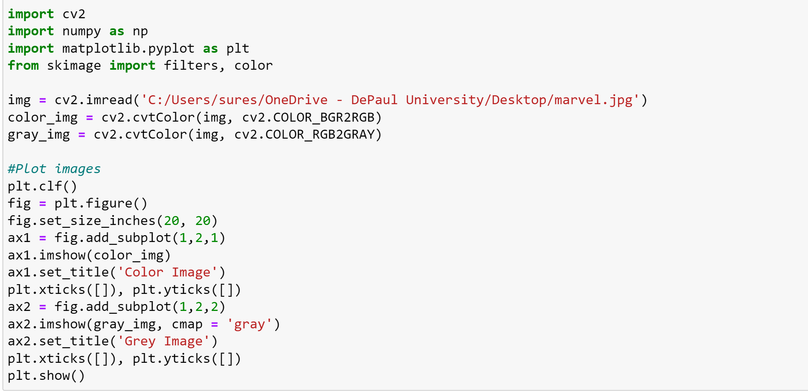

**Output:**



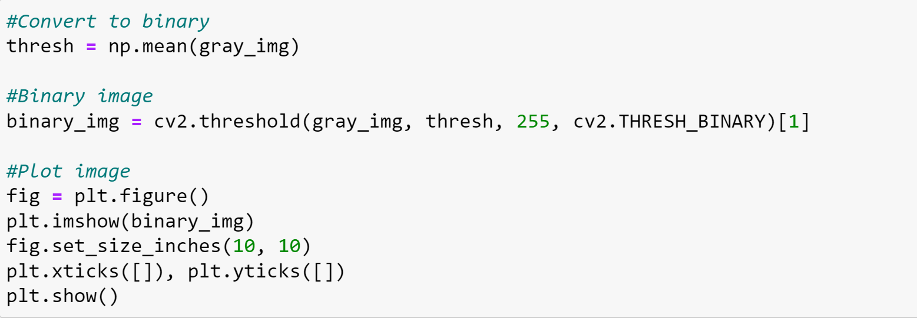

**Output:**



**Normal Kernel:**

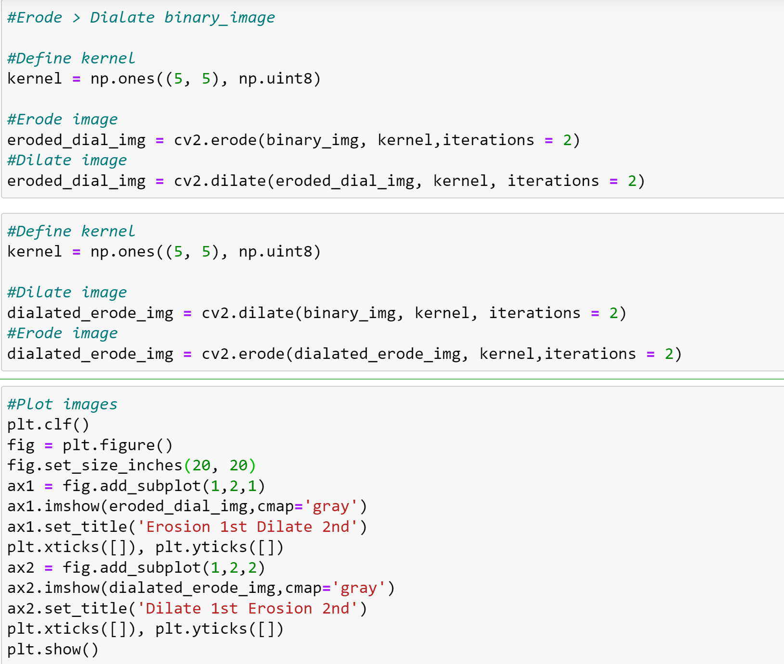

**Output:**

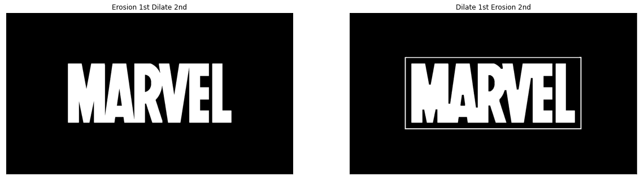

Applying erosion 1st and dilate 2nd doesn’t capture the grid that is around the word. It mostly captures the darker image. Whereas the vice versa captures the grid which is a lighter area and is present in the second version.

**Generate structured kernel:**

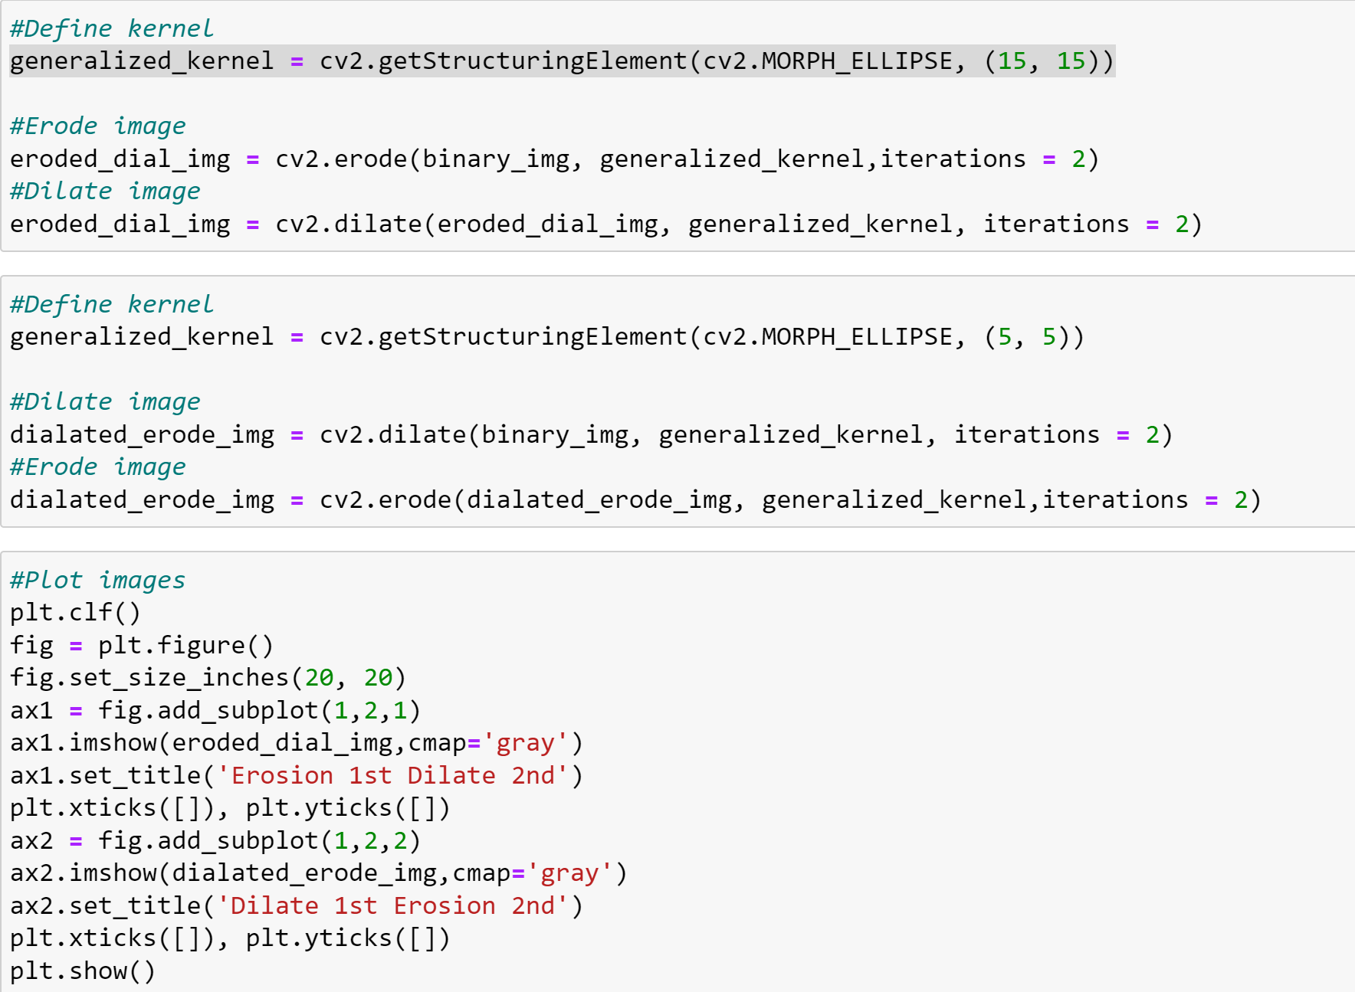

**Output:**

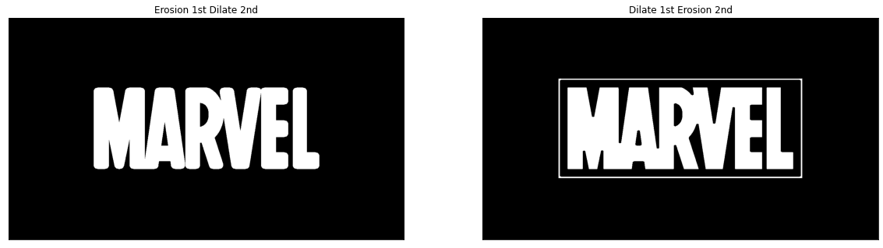

Using the generalized structured kernel, we can see the shape is curved around the edges of the words in the first image that is the 1st erosion and 2nd dilate. Whereas the other side doesn’t face this issue.

**Problem 2: Opening and Closing**

**Normal Kernel:**

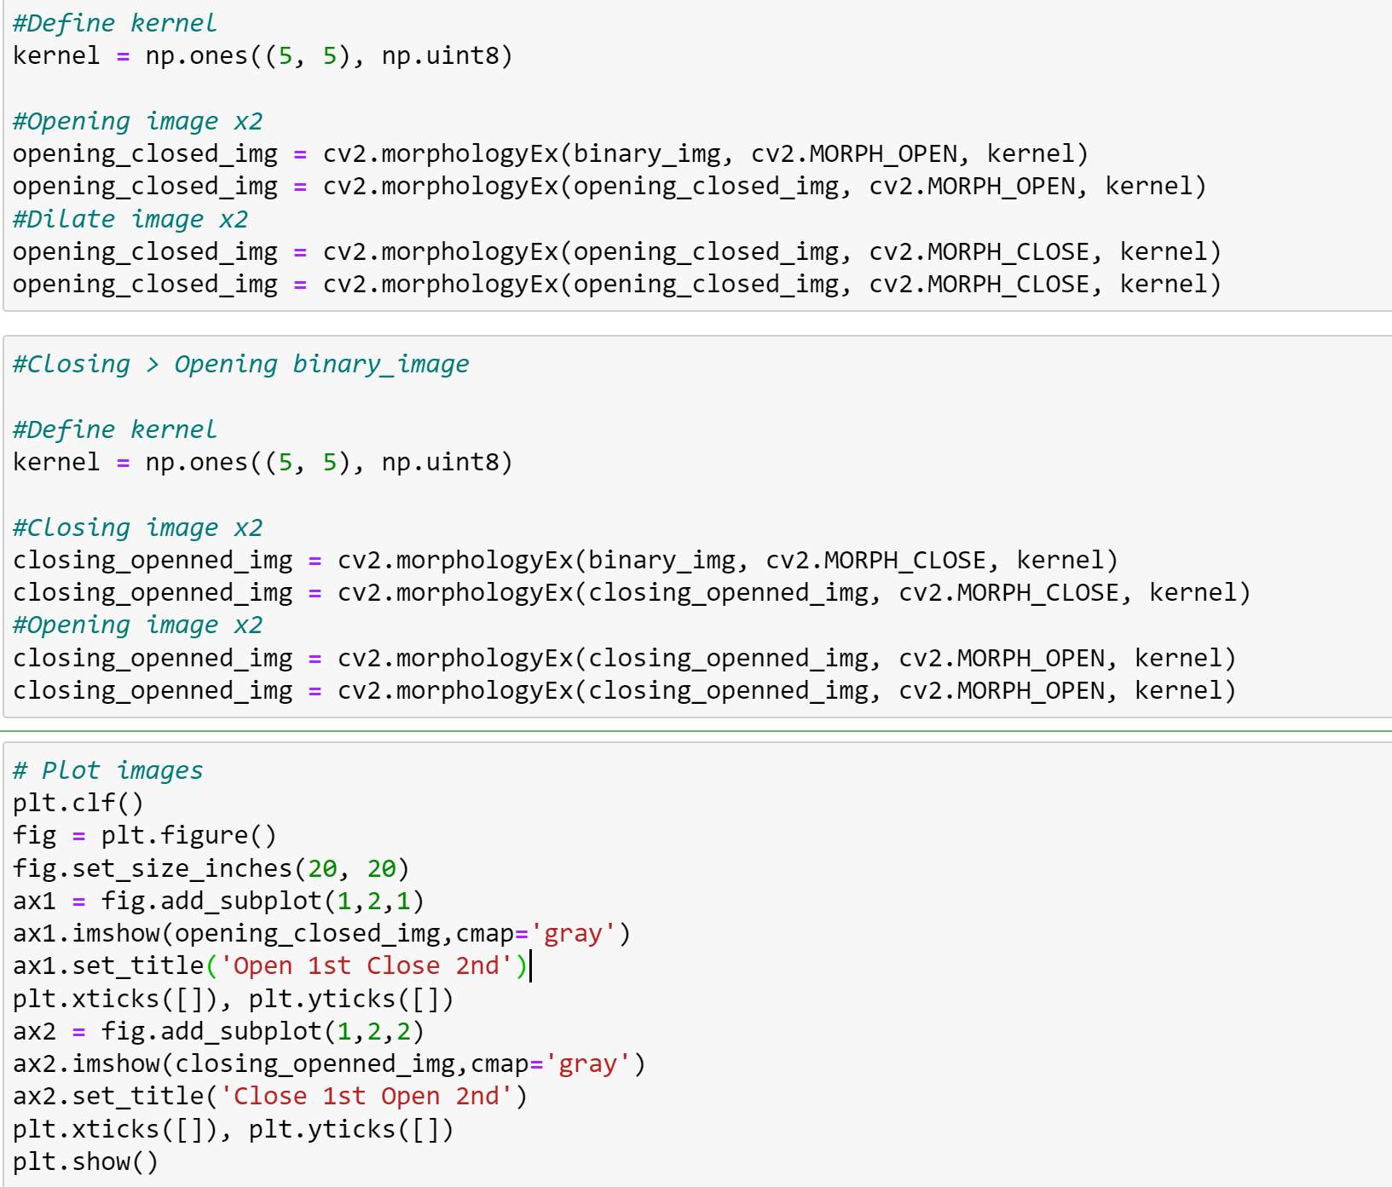

**Output:**



By comparing with the problem 1 here there is no difference between which is done first but the line in the upper grid is totally removed but still captures some of the darker areas too.

**Generate structured kernel:**

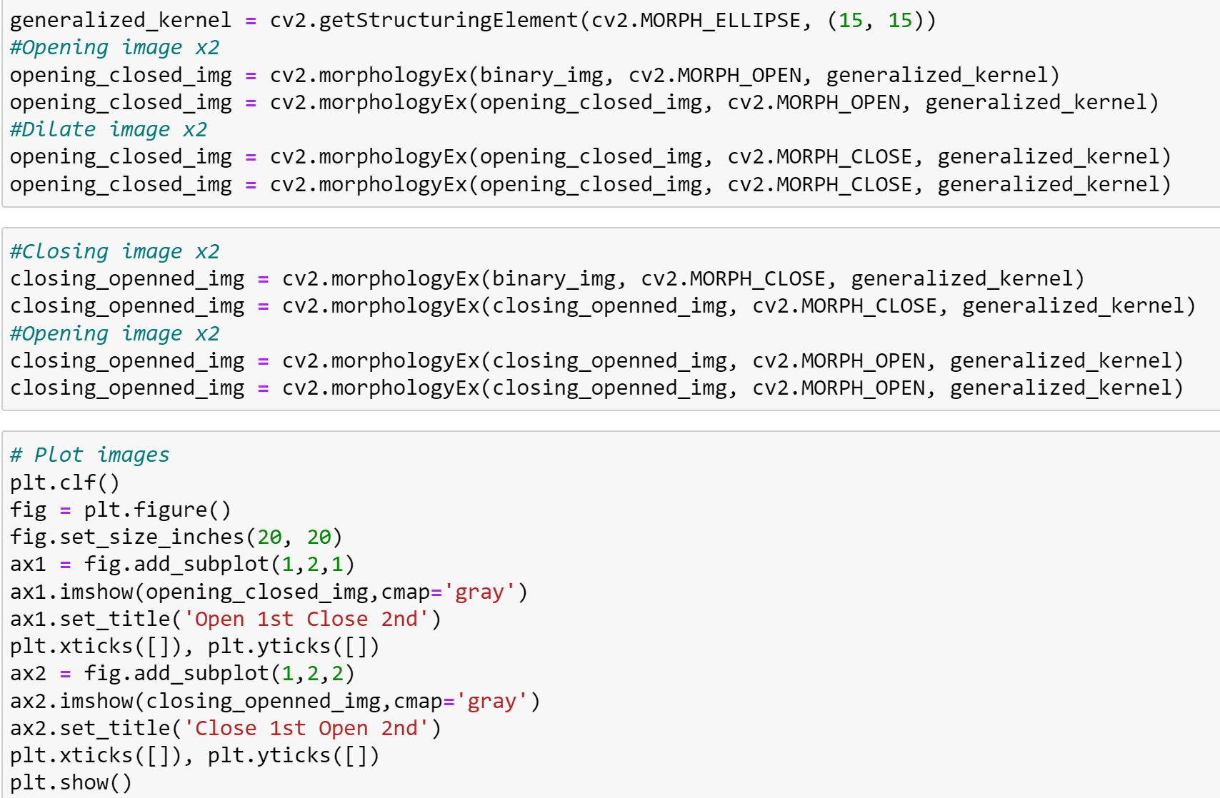

**Output:**

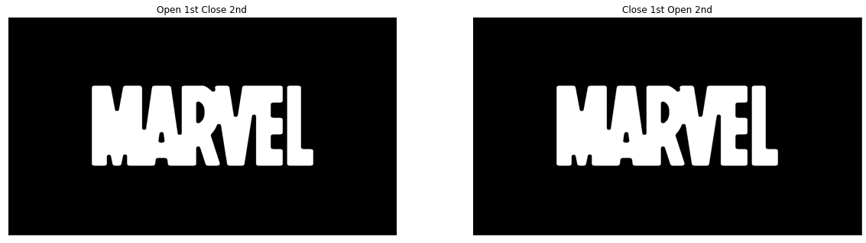

In the generalized structured kernel the letters are looking like they are over filled and the grid is not present in both the cases.

**Problem 3: Boundary Extraction**

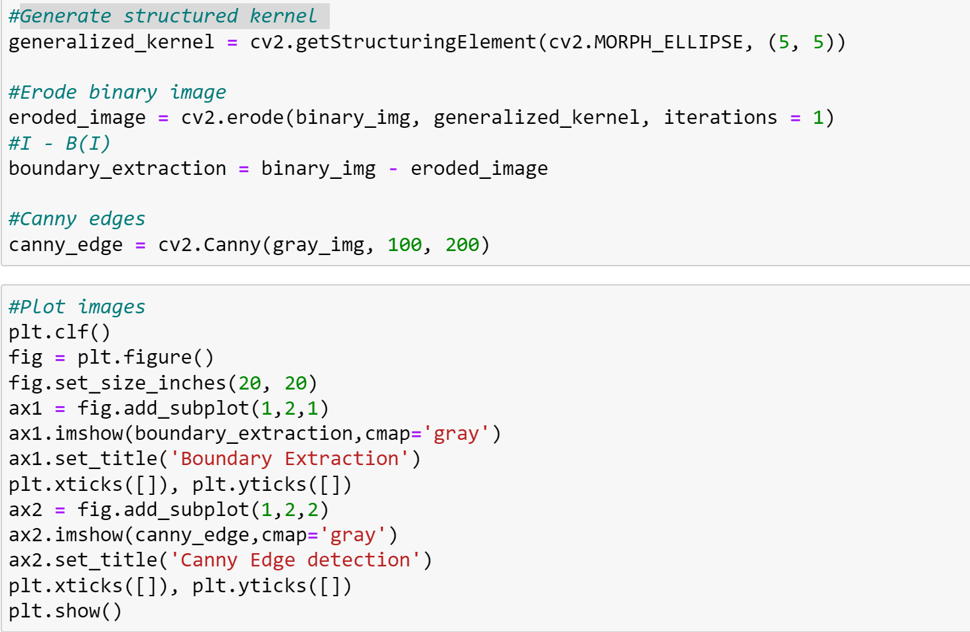

**Output:**

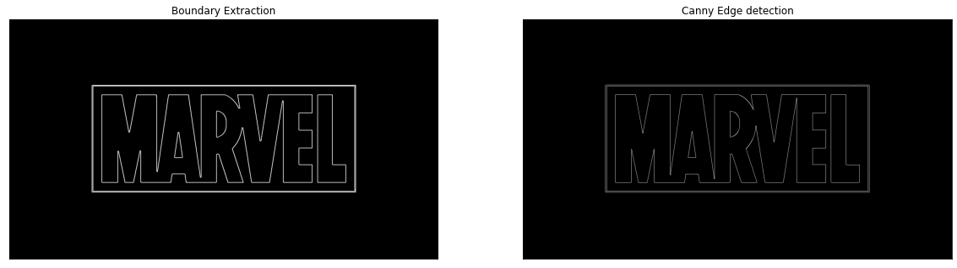

The boundary extraction method captures the boundary better than the canny edge detection. The grid and the letters are more visible in the boundary extraction method rather than the canny edge detection method.